1)a)import java.util.Scanner;

public class HelloWorld{

public static void main(String args[]){

System.out.println(“Akshara Singa”);

System.out.println(“1BM22CS029”);

Scanner reader = new Scanner(System.in);

int number = reader.nextInt();

System.out.println(“You entered :” +number);}

}

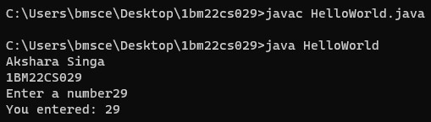

b)import java.util.Scanner;

public class JavaExample{

public static void main(String args[]){

System.out.println(“Akshara Singa”);

System.out.println(“1BM22CS029”);

int num;

System.out.println(“Enter an Integer number”);

Scanner input = new Scanner(System.in);

num = input.nextInt();

if(num%2==0){

System.out.println(num+“is even number”);

}

else{

System.out.println(num+“is odd number”);

}

}}

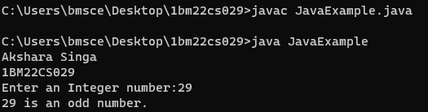

c)public class JavaExample {

public static void main(String args[]){

System.out.println(“Akshara Singa”);

System.out.println(“1BM22CS029”);

int row, column ,no_of_rows=8;

for(row=0;row<no_of_rows;row++){

for(column=0;column<row;column++){

System.out.println(“*”);}}}}

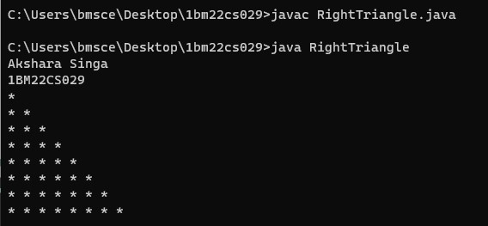

d)public class JavaExample{

public static void main(String args[]){

System.out.println(“Akshara Singa”);

System.out.println(“1BM22CS029”);

int num1=15,num2=2;

int Quotient =num1/num2;

int remainder=num1%num2;

System.out.println(“Qutoient is” +Quotient);

System.out.println(“Remainder is” +remainder);}}

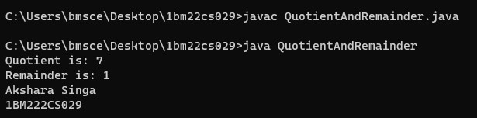

e)public class demo{

public static void main(String args[]){

System.out.println(“Akshara singa”);

System.out.println(“1BM22CS029”);

Scanner scan = new Scanner(System.in);

System.out.println(“Enter first number”);

int num1=scan.nextInt();

System.out.println(“Enter second number”);

int num2=scan.nextInt();

scan.close();

int product=num1*num2;

System.out.println(“Output:”+product);}}

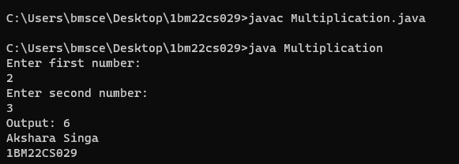

f)public class swapnumbers{

public static void main(String args[]){

System.out.println(“Akshara Singa”);

System.out.println(“1BM22CS029”);

float first =1.20f,second=2.45f;

System.out.println(“—Before Swap—“);

System.out.println(“First number”+first);

System.out.println(“Second number”+second);

Float temp=first;

first=second;

second=temp;

System.out.println(“—After Swap—“);

System.out.println(“First number”+first);

System.out.println(“Second number”+second);}}

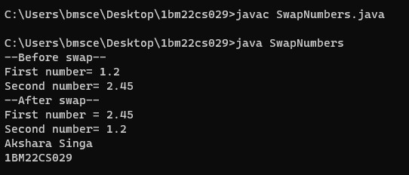

2)import java.util.Scanner;

public class QuadraticSolver {

public static void main(String[] args) {

System.out.println(“Akshara Singa”);

System.out.println(“1BM22CS029”);

Scanner scanner = new Scanner(System.in);

System.out.println("Enter the coefficients of the quadratic equation ax^2 + bx + c = 0:");

System.out.print("Enter a: ");

double a = scanner.nextDouble();

System.out.print("Enter b: ");

double b = scanner.nextDouble();

System.out.print("Enter c: ");

double c = scanner.nextDouble();

double discriminant = b * b - 4 * a * c;

if (discriminant > 0) {

double root1 = (-b + Math.sqrt(discriminant)) / (2 * a);

double root2 = (-b - Math.sqrt(discriminant)) / (2 * a);

System.out.println("Real Solutions:");

System.out.println("Root 1: " + root1);

System.out.println("Root 2: " + root2);

} else if (discriminant == 0) {

double root = -b / (2 * a);

System.out.println("Real Solution:");

System.out.println("Root: " + root);

} else {

System.out.println("No real solutions exist for the given quadratic equation.");

}

scanner.close();

}

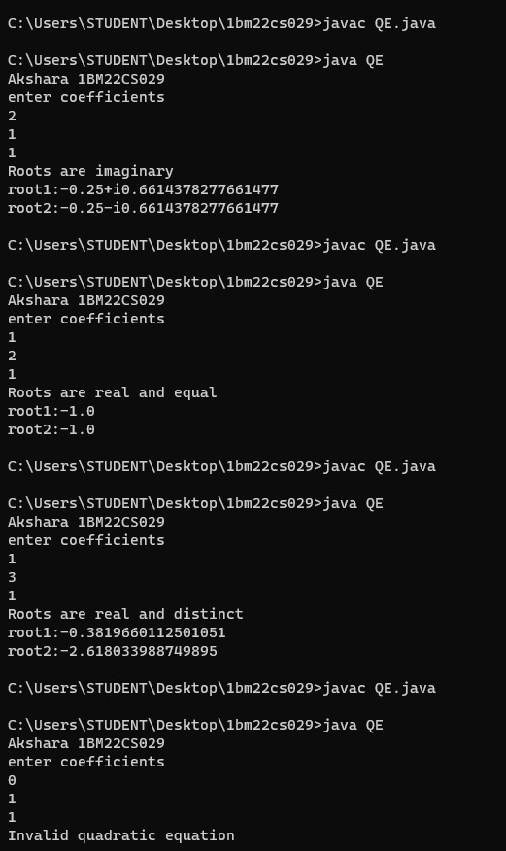

3)import java.util.Scanner;

public class Student {

String usn;

String name;

private static int credit[] = {4,4,3,3,3,1,1,1};

int marks[] = new int [8];

System.out.println(“Akshara Singa”);

System.out.println(“1BM22CS029”);

Scanner s = new Scanner(System.in);

public void get_details()

{

System.out.println("Enter your USN:");

usn = s.next();

System.out.println("Enter your name:");

name = s.next();

}

public void set_marks()

{

System.out.println("Enter your marks in order");

for(int i=0;i<8;++i)

{

marks[i] = s.nextInt();

}

}

public double sgpa()

{

double sgpa=0,temp=0;

for(int i=0;i<8;++i)

{

temp+=credit[i]*((int)(marks[i]/10)+1);

}

sgpa= temp/20;

if(sgpa == 11)

{

return sgpa-1;

}

return sgpa;

}

public void display()

{

System.out.println("Name: "+name);

System.out.println("USN: "+usn);

System.out.println("SGPA: "+sgpa());

}

public static void main(String[] args) {

Student s1 = new Student();

s1.get_details();

s1.set_marks();

s1.display();

}

}

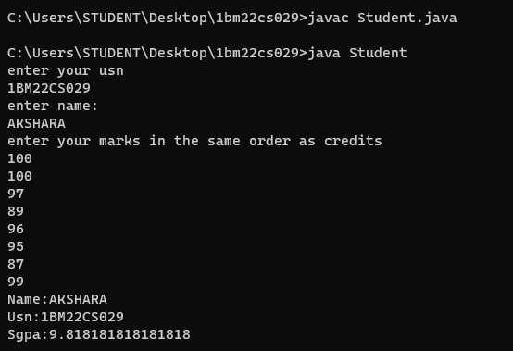

4)import java.util.Scanner;

class Books{

String name;

String author;

int price;

int num_pages;

public void set(int i){

Scanner in=new Scanner(System.in);

System.out.println("Enter details of books "+(i+1)+" in name,author,price,num_pages order");

name=in.next();

author=in.next();

price=in.nextInt();

num_pages=in.nextInt();

}

public String toString() {

return "Details of Book " + (i+1)+"\n"+

"Name: " + name + "\n" +

"Author: " + author + "\n" +

"Price: " + price + "\n" +

"No of pages: " + num_pages;

}

}

class D {

public static void main(String[] args) {

int n;

System.out.println(“Akshara Singa”);

System.out.println(“1BM22CS029”);

Scanner in=new Scanner(System.in);

System.out.println("Enter number of books");

n=in.nextInt();

Books b[]=new Books[n];

for(int i=0;i<n;i++){

b[i]=new Books();

b[i].set(i);

}

System.out.println();

for(int i=0;i<n;i++){

System.out.println(b[i].toString());

}

}

}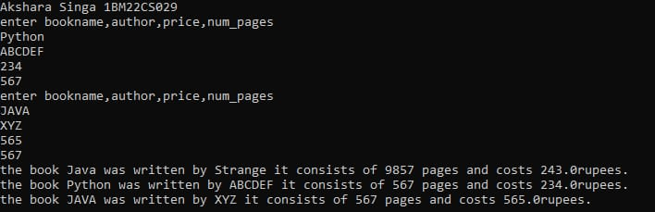

5)import java.util.Scanner;

abstract class Shape {

protected int side1;

protected int side2;

public Shape(int side1, int side2) {

this.side1 = side1;

this.side2 = side2;

}

public abstract void printArea();

}

class Rectangle extends Shape {

public Rectangle(int length, int width) {

super(length, width);

}

public void printArea() {

int area = side1 * side2;

System.out.println("Area of Rectangle: " + area);

}

}

class Triangle extends Shape {

public Triangle(int base, int height) {

super(base, height);

}

public void printArea() {

double area = 0.5 * side1 * side2;

System.out.println("Area of Triangle: " + area);

}

}

class Circle extends Shape {

public Circle(int radius) {

super(radius, radius);

}

public void printArea() {

double area = Math.PI * side1 * side1;

System.out.println("Area of Circle: " + area);

}

}

public class Main {

public static void main(String[] args) {

System.out.println(“Akshara Singa”);

System.out.println(“1BM22CS029”);

Scanner scanner = new Scanner(System.in);

System.out.print("Enter length of Rectangle: ");

int length = scanner.nextInt();

System.out.print("Enter width of Rectangle: ");

int width = scanner.nextInt();

Rectangle rectangle = new Rectangle(length, width);

System.out.print("Enter base of Triangle: ");

int base = scanner.nextInt();

System.out.print("Enter height of Triangle: ");

int height = scanner.nextInt();

Triangle triangle = new Triangle(base, height);

System.out.print("Enter radius of Circle: ");

int radius = scanner.nextInt();

Circle circle = new Circle(radius);

scanner.close();

rectangle.printArea();

triangle.printArea();

circle.printArea();

}

}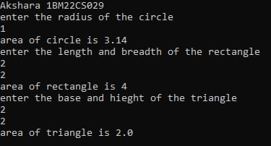

6)import java.util.Scanner;

class Account {

String customerName;

long accno;

String accountType;

double balance;

public Account(String customerName, long accno, String accountType) {

this.customerName = customerName;

this.accno = accno;

this.accountType = accountType;

this.balance = 0.0;

}

public void displayBalance() {

System.out.println("Account Number: " + accno);

System.out.println("Customer Name: " + customerName);

System.out.println("Account Type: " + accountType);

System.out.println("Balance: $" + balance);

}

}

class CurAcct extends Account {

double minBalance;

double serviceCharge;

public CurAcct(String customerName, long accno) {

super(customerName, accno, "Current");

this.minBalance = 500.0; // Set minimum balance

this.serviceCharge = 50.0; // Set service charge

}

public void withdraw(double amount) {

if (balance - amount >= minBalance) {

balance -= amount;

System.out.println("Withdrawal successful. Current Balance: $" + balance);

} else {

System.out.println("Insufficient funds. Withdrawal not allowed.");

}

}

public void imposeServiceCharge() {

if (balance < minBalance) {

balance -= serviceCharge;

System.out.println("Service charge imposed. Current Balance: Rs." + balance);

}

}

}

class SavAcct extends Account {

double interestRate;

public SavAcct(String customerName, long accno) {

super(customerName, accno, "Savings");

this.interestRate = 0.05;

}

public void depositInterest() {

double interest = balance * interestRate;

balance += interest;

System.out.println("Interest deposited. Current Balance: $" + balance);

}

public void compoundInterest(double initialAmount, int term) {

double compoundInterest = initialAmount * Math.pow((1 + interestRate), term) - initialAmount;

balance += compoundInterest;

System.out.println("Compound Interest deposited. Current Balance: Rs." + balance);

}

}

public class Bank {

public static void main(String[] args) {

System.out.println(“Akshara Singa”);

System.out.println(“1BM22CS029”);

Scanner scanner = new Scanner(System.in);

System.out.println("Choose account type:");

System.out.println("1. Current");

System.out.println("2. Savings");

System.out.print("Enter choice (1 or 2): ");

int choice = scanner.nextInt();

System.out.print("Enter customer name: ");

String customerName = scanner.next();

System.out.print("Enter account number: ");

long accno = scanner.nextLong();

if (choice == 1) {

CurAcct curAccount = new CurAcct(customerName, accno);

System.out.print("Enter initial balance: $");

double initialBalance = scanner.nextDouble();

curAccount.balance = initialBalance;

System.out.print("Enter withdrawal amount: $");

double withdrawalAmount = scanner.nextDouble();

curAccount.withdraw(withdrawalAmount);

curAccount.imposeServiceCharge();

curAccount.displayBalance();

} else if (choice == 2) {

SavAcct savAccount = new SavAcct(customerName, accno);

System.out.print("Enter initial balance: $");

double initialBalance = scanner.nextDouble();

savAccount.balance = initialBalance;

System.out.print("Enter withdrawal amount: $");

double withdrawalAmount = scanner.nextDouble();

savAccount.balance -= withdrawalAmount;

System.out.println("Withdrawal successful. Current Balance: $" + savAccount.balance);

System.out.print("Enter interest rate: ");

double interestRate = scanner.nextDouble();

savAccount.interestRate = interestRate;

savAccount.displayBalance();

System.out.print("Enter term (in years) for compound interest calculation: ");

int term = scanner.nextInt();

savAccount.compoundInterest(initialBalance, term);

savAccount.displayBalance();

} else {

System.out.println("Invalid choice");

}

}

}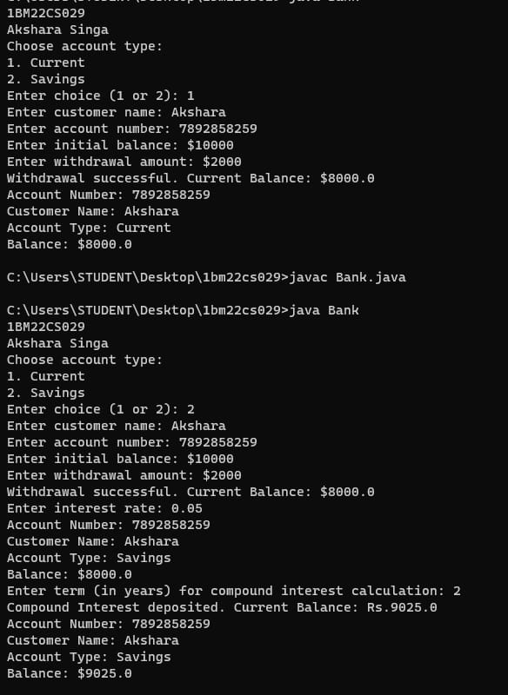

7)package CIE;

import java.util.*;

public class Student

{

// instance variables - replace the example below with your own

public int sem;

public String usn;

public String name;

public void accept()

{

Scanner scan = new Scanner(System.in);

System.out.println("Enter U, N, S:\n");

usn=scan.nextLine();

name=scan.nextLine();

sem=scan.nextInt();

}

}

package CIE;

public class Internals

{

public int im[]=new int[5];

}

package SEE;

import CIE.Student;

public class External extends Student

{

// instance variables - replace the example below with your own

public int sm[]=new int[5];

}

import java.util.*;

import SEE.*;

import CIE.*;

public class FinalMarks

{

public static void main(String args[])

{System.out.println("Akshara Singa");

System.out.println("1BM22CS029");

int fm[]=new int[5];

Scanner sc= new Scanner(System.in);

System.out.println("Enter n: ");

int n=sc.nextInt();

SEE.External st[]=new SEE.External[n];

CIE.Internals s[]=new CIE.Internals[n];

for(int i=0; i<n; i++)

{

st[i]=new SEE.External();

s[i]=new CIE.Internals();

System.out.println("Enter details "+(i+1));

st[i].accept();

for(int j=0; j<5; j++)

{

System.out.println("Enter im and sm of sub "+(j+1));

s[i].im[j]=sc.nextInt();

st[i].sm[j]=sc.nextInt();

fm[j]=s[i].im[j]+st[i].sm[j];

}

System.out.println("Final marks of "+st[i].name);

for(int k=0; k<5; k++)

{

System.out.println("Course "+(k+1)+" = "+fm[k]);

}

}

}

}

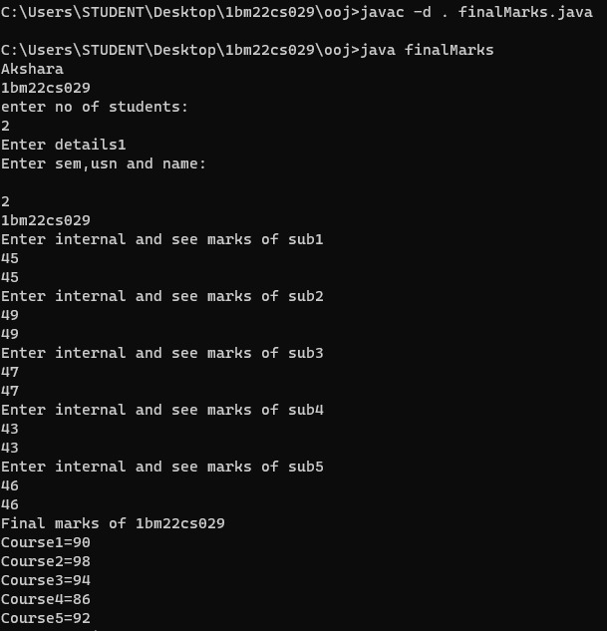

8)import java.util.Scanner;

class WrongAge extends Exception {

public WrongAge(String message) {

super(message);

}

}

class Father {

int fatherAge;

public Father(int fatherAge) throws WrongAge {

if (fatherAge < 0) {

throw new WrongAge("Age cannot be negative");

}

this.fatherAge = fatherAge;

}

}

class Son extends Father {

int sonAge;

public Son(int fatherAge, int sonAge) throws WrongAge {

super(fatherAge);

if (sonAge >= fatherAge) {

throw new WrongAge("Son's age must be less than Father's age");

}

this.sonAge = sonAge;

}

}

public class fatherson {

public static void main(String[] args) {

System.out.println(“Akshara Singa”);

System.out.println(“1BM22CS029”);

Scanner sc = new Scanner(System.in);

System.out.println("Enter father's age and son's age: ");

int fa=sc.nextInt();

int sa=sc.nextInt();

try {

Son s = new Son(fa, sa);

System.out.println("Father's age: " + s.fatherAge);

System.out.println("Son's age: " + s.sonAge);

} catch (WrongAge e) {

System.out.println("Error: " + e.getMessage());

}

}

}

9)class A extends Thread

{

int t1,time;

A(){

t1=10000;

time=21000;

}

public void run()

{

while(t1<=time)

{

System.out.println("BMS COLLEGE OF ENGINEERING");

try {

sleep(10000);

} catch(Exception e) {

System.out.println("error");

}

t1+=10000;

}}

}

class B extends Thread{

int t2,time;

B(){

time=21000;

t2=2000;

}

public void run()

{

while(t2<=time)

{

System.out.println("CSE");

try{

sleep(2000);

}

catch(Exception e)

{

System.out.println("error");

}

t2+=2000;

}}

}

class th

{

public static void main(String args[])

{ System.out.println(“Akshara.Singa”);

System.out.println(“1BM22CS029”);

A a=new A();

B b=new B();

a.start();

b.start();

}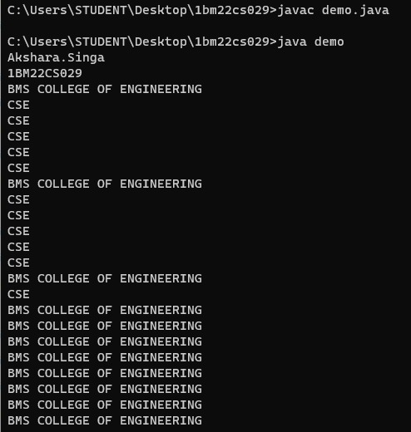

10)import javax.swing.*;

import java.awt.*;

import java.awt.event.*;

class SwingDemo{

SwingDemo(){

JFrame jfrm = new JFrame("Divider App");

jfrm.setSize(275, 150);

jfrm.setLayout(new FlowLayout());

jfrm.setDefaultCloseOperation(JFrame.EXIT_ON_CLOSE);

JLabel jlab = new JLabel("Enter the divider and divident:");

JTextField ajtf = new JTextField(8);

JTextField bjtf = new JTextField(8);

JButton button = new JButton("Calculate");

JLabel err = new JLabel();

JLabel alab = new JLabel();

JLabel blab = new JLabel();

JLabel anslab = new JLabel();

jfrm.add(err);

jfrm.add(jlab);

jfrm.add(ajtf);

jfrm.add(bjtf);

jfrm.add(button);

jfrm.add(alab);

jfrm.add(blab);

jfrm.add(anslab);

ActionListener l = new ActionListener() {

public void actionPerformed(ActionEvent evt) {

System.out.println("Action event from a text field");

}

};

ajtf.addActionListener(l);

bjtf.addActionListener(l);

button.addActionListener(new ActionListener() {

public void actionPerformed(ActionEvent evt) {

try{

int a = Integer.parseInt(ajtf.getText());

int b = Integer.parseInt(bjtf.getText());

int ans = a/b;

alab.setText("\nA = " + a);

blab.setText("\nB = " + b);

anslab.setText("\nAns = "+ ans);

}

catch(NumberFormatException e){

alab.setText("");

blab.setText("");

anslab.setText("");

err.setText("Enter Only Integers!");

}

catch(ArithmeticException e){

alab.setText("");

blab.setText("");

anslab.setText("");

err.setText("B should be NON zero!");

}

}

});

jfrm.setVisible(true);

}

public static void main(String args[]){

System.out.println(“Akshara Singa”);

System.out.println(“1BM22CS029”);

SwingUtilities.invokeLater(new Runnable(){

public void run(){

new SwingDemo();

}

});

}

}